

Roots
Andy Lincoln, Daniel Kolsoi
UMass Lowell
91.462 – GUI Programming II

Table of Contents
Contents
Project Goal 2
Features 2
Core Features 2
Potential Features 2
Unlikely Features 3
User Descriptions 3
Components 3
Existing Software as a Model 3
Libraries 3
Interface Components 3
Issues 4
Physics Based Nodes 4
Database 4
Responsive Design 4
Schedule 5
Criteria of Acceptability 7

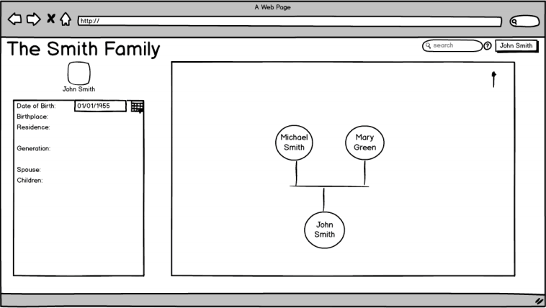
Figure 1- A mockup depicting the fictional Smith Family

Project Goal
We will create a web based service for users to compile an elegant and informative family tree that can be shared through the Internet.

Features

Core Features
Our web service will have circular nodes that are drawn onto the HTML5 canvas. A node will represent a person and can have a picture uploaded and replace it visually. A relationship indicator will visibly signify the type of relationship between two nodes. For example, two people might not be related by blood and so the connection will look different than the standard connection between two blood relatives. On the left side of the canvas there will be a detail panel, as shown in figure 1, which will provide a place to enter and view biographical information about a person. A generation counter that will count the number of generations between two nodes would also be included. Other basic canvas manipulation features such as being able to scroll through large family trees are essential. Later on, we plan on including the ability to generate non-editable trees for sharing.

Potential Features
There are some features that we would like to implement but may not have the time to include. Among this list includes a search function that will allow our users to find people in large trees with ease. Another idea is to be able to import information from Wikipedia if a particular person in the family tree has his or her own article. We also are exploring the possibility of requiring user accounts, using Facebook or Google account integration. These features are not core to the project goal and can be implemented once the core of our project has reached an acceptable state.
The ability to merge separate trees could be useful to users as well, as our users will likely share with members of their own families. This would allow other family members to contribute and expand the existing trees. As these trees grow, questions regarding relationships will as well. For this reason we can also construct abilities to compare people within the tree and display their relationship.

Unlikely Features
A couple features were thought up that are certainly beyond the scope of this project but were considered nonetheless. One idea was to have a list of major world events that occurred during the person’s lifetime generated automatically. This list would be used by our users to gain context about the lives of other members of their families. Location based personal stories via Google Maps integration was also considered, but has been deemed adventurous and will likely not make it to the finished product.

User Descriptions
Our target user base is aimed at young to middle-aged adults with an interest in genealogy. It will however have the potential for academic use.

Components

Existing Software as a Model
- Ancestry.com
- Geni.com

Libraries
- jQueryUI for organizational tools and user interface components
- jQuery to power jQueryUI and provide functional tools
- Box2Djs to create the tree workspace

Interface Components
- Detail Panel that can be pinned to the screen
- HTML5 Canvas workspace
- User Information / Search bar

Issues

Physics Based Nodes
Our current plan is to integrate the Box2Djs physics engine into our web application, which would make connecting nodes to each other much more visually appealing. However, this idea may possibly be scrapped early on if we determine that the library’s API will be very time consuming to learn or if it will potentially interfere with the user’s experience. Furthermore, it would be a purely aesthetic feature and therefore would not be something we would want to spend too much time on.

Database
Databases are useful tools in creating robust web applications, and an application such as this could benefit greatly from one in order to keep track of users and the information they contribute to their trees. However, databases can be tricky to manage and it is necessary to be thorough in the planning and execution of integrating these components. As useful a tool a database may be, our intent is to create family trees, not family databases. Our top priority must remain with the front end and the user experience.

Responsive Design
Responsive web design is a key element of user experience on the Internet, and it is a “feature” that has now become an expectation of users when viewing pages. In order to live up to this expectation, our application will have to behave consistently across multiple browsers and even more screen sizes. As shown in figure 2, different browsers interpret web pages in their own ways, as HTML5 support is not uniform across the board, which could lead to inconsistencies in the user experience.
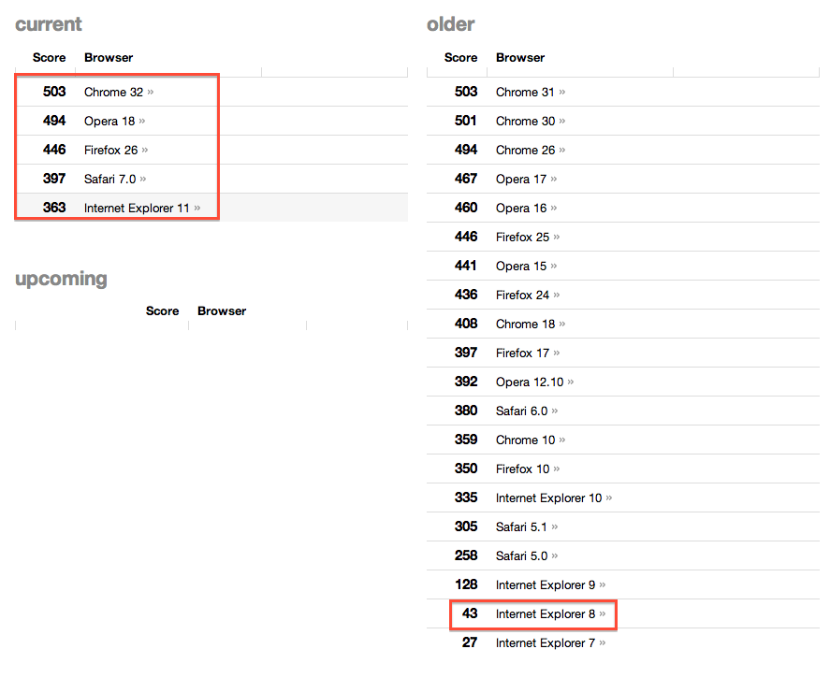
Figure 2 – HTML5 compliance test with commonly used web browsers.

Furthermore, an issue may lie in our user's choice of devices as well as web browsers. In order to utilize the HTML5 canvas our users must be using an HTML5 compliant browser, which could be an issue. As of this writing, Windows XP is still going strong in the United States, with 29% of internet users reporting. Unfortunately, Internet Explorer 8 (IE8) is the highest version of IE that is available to XP, and has a 21% share of Internet traffic. This is significant as IE8 supports little of the HTML5 standard. (NetMarketShare December 2013)

Schedule
Date | Goal | Assignee
Jan 26th | GitHub Source Control  We will have our GitHub accounts and project repository created. Basic files will be added and push permissions will be granted to the student not hosting the repository. | Dan & Andy
Jan 29th | Initial Research  Dan will research how much time and effort the Box2Djs API will require to learn and use. Andy will take a look at various libraries that will make data storage and retrieval easier. | Dan & Andy
Feb 4th | Proposal Due  Our project proposal will be completed, looked over, and turned in. | Dan & Andy
Feb 14th | Physics Engine  A demo will be created using the physics engine in such a way that lays the foundation for the primary user interface within the html canvas. | Dan
Feb 14th | Data Structure  Data structures utilizing any required libraries will be completed. This will allow for data to be easily accessible and formatted from within the detail panel. | Andy
Feb 20th | User Interface  The primary user interface containing the canvas and its interactive components will be moved to a new web page. It will be merged with a detail panel consisting of relevant information from our previously created data structures. | Dan & Andy
Feb 25/27th | Alpha Version  By the alpha release, we will have core functionality implemented. The webpage will be as polished and debugged as time permits. | Dan & Andy
Mar 31th | Live Tutorial  A tutorial will be implemented which will directly show the users where and what to click to use the basic features. If this feature is completed ahead of time, additional features will be added from the potential features section. | Dan
Mar 31th | Permanent Link Sharing  A feature will be added which will allow the user to share his or her created family tree with another person via a url. If this feature is completed ahead of time, additional features will be added from the potential features section. | Andy
Apr 3rd | Beta Version and Usability Tests  By the beta release, our project will have our non-core features such as the live tutorial and permanent links implemented. We will then be doing usability tests to see how people react to using our website. | Dan & Andy
Apr 24/29th | Project In-Class Presentations  Our project will have been completed and polished by the day of our presentation before our class. | Dan & Andy
May 6th | Venture Forum Presentations  Our final version will be presented before the Merrimack Valley Venture Forum | Dan & Andy

Criteria of Acceptability
- Can create as well as remove nodes, edit and view data relevant to that person.
- Sharing read-only versions of trees.
- Having an interactive canvas that can be expanded, drag and drop to connect nodes.

